**PSG COLLEGE OF TECHNOLOGY-COIMBATORE**

**DEPARTMENT OF APPLIED MATHEMATICS AND COMPUTATIONAL SCIENCES**

**III Sem MSc Software Systems - 18XW38 - RDBMS LAB**

**Problem Sheet – IX**

1. Consider the following Human Resource Schema (HR).

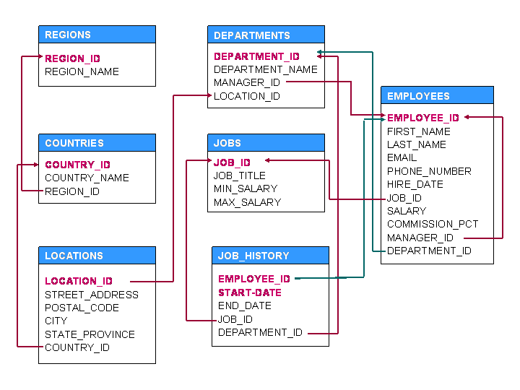

**Note:**Columns in RED color indicate primary key(s).

1. Insert data into these tables.
2. Write PL/SQL procedures/functions/triggers for the following.
3. Increase the salary of employee 115 based on the following conditions:

If experience is more than 10 years, increase salary by 20%

If experience is greater than 5 years, increase salary by 10%

Otherwise, increase salary by 5%

1. Change commission percentage as follows for employee with ID = 150.

If salary is more than 10000 then commission is 0.4%

If Salary is less than 10000 but experience is more than 10 years then 0.35%

If salary is less than 3000 then commission is 0.25%.

In the remaining cases, commission is 0.15%.

1. Find the employee name and department name of an employee who is managing employee 103.
2. Display the missing employee IDs.
3. Display the year in which maximum number of employees joined along with how many have joined in each month in that year.
4. Change salary of employee 130 to the salary of the employee with first name ‘Joe’. If Joe is not found then take average salary of all employees. If more than one employee with first name ‘Joe’ is found then take the least salary of the employees with first name Joe.
5. Display Job Title and Name of the Employee who joined the job first day.
6. Display 5th and 10th employees in Employees table.
7. Update salary of an employee based on department and commission percentage.

If department number is 40 increase salary by 10%

If department number is 70 then 15%

If commission is more than .3% then 5% otherwise 10%

1. Write a function that takes department ID and returns the name of the manager of the department.
2. Write a function that takes employee ID and return the number of jobs done by the employee in the past.
3. Write a procedure that takes department ID and changes the manager ID for the department to the employee in the department with highest salary.
4. Write a function that takes a manager ID and return the names of employees who report to this manager. The names must be returned as a string with comma separating names.
5. Ensure no changes can be made to EMPLOYEES table before 6am and after 10pm in a day.
6. Write a Trigger to ensure the salary of the employee is not decreased.
7. The employees’ salary is to be classified as following:

Class A: <= 30000

Class B: > 30000 and <= 60000

Class C: > 60000

Create a function to return the class of a salary for an employee, given his or her ID.